***PAAREES PERFUMES***

***VERSACE***

***FOR WOMEN***

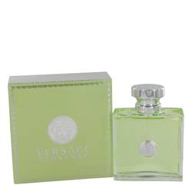

# 

# *Versace Versense*

# *Description:*

Versace Versense by Versace Perfume. Bring brilliance to your day when you wear Versace Versense, a sweet, aromatic scent for women from the iconic design house of Versace. Designed for the fashion-forward woman who revels in the excitement of the runway, this scent was released in 2009 and features a citrus and wood blend of fresh and spicy notes. Wear it to add a vibe of powerful femininity to your persona before a big meeting with Vip clients or a date with Mr. Right..